**HTML Link Bookmarks**

**HTML Links - Create Bookmarks:**

HTML links can be used to create bookmarks, so that readers can jump to specific parts of a web page.

**Example:**





**What is Bookmarks?**

**Write the exact definition of Bookmarks here!**

Bookmarks can be useful if a web page is very long.

We can create a bookmark of a specific part of same webpage in which we are present, if the webpage is too long.

With the help of bookmarks we can go to any specific part of the same webpage in which we are present.

**Create a Bookmark in HTML:**

To create a bookmark - first create the bookmark/use the ***id***attribute in HTML element and give value to ***id*** attribute, then add a link to it using ***anchor tag***.

**Note:** Must write “***#***”before ***id*** value in value of “***href***” attribute. Otherwise bookmark link will not work.

When the link is clicked, the page will scroll down or up to the location with the bookmark.

**Example:**

If we have “***8 sections***”in a webpage, and we want to direct go/jump to “***8th section***” from 1st section, so this is possible when we create a link of that section at the top of webpage using bookmarks and then we click on it, we direct jump to the “***section 8th***”.

**Code:**

***There are 8th sections in a webpage:***

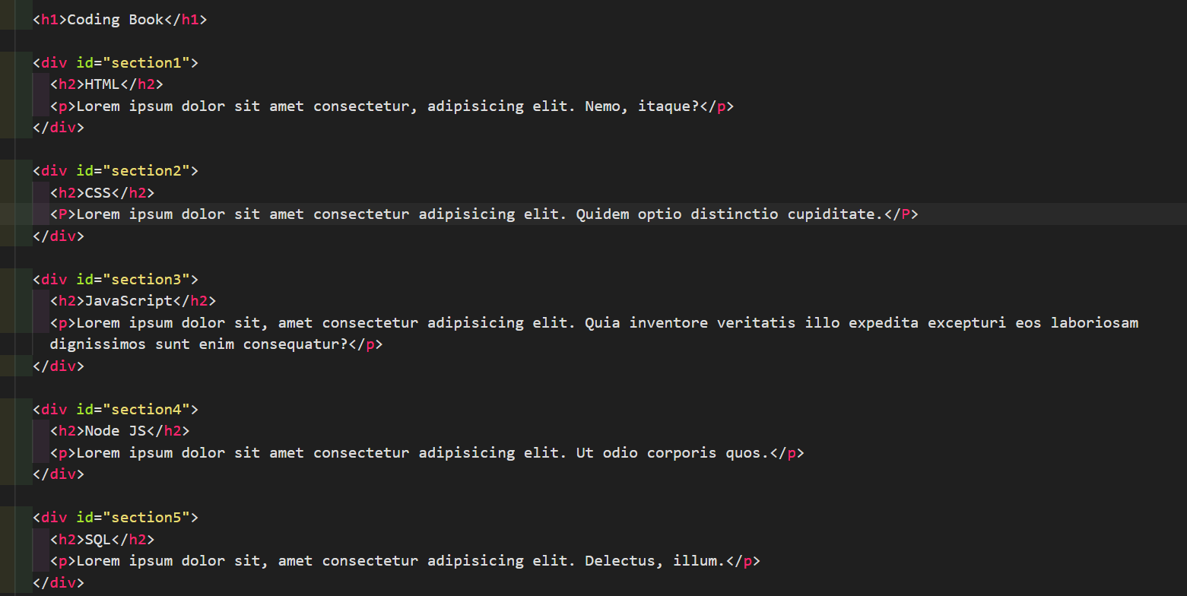

***Output of the above code:***

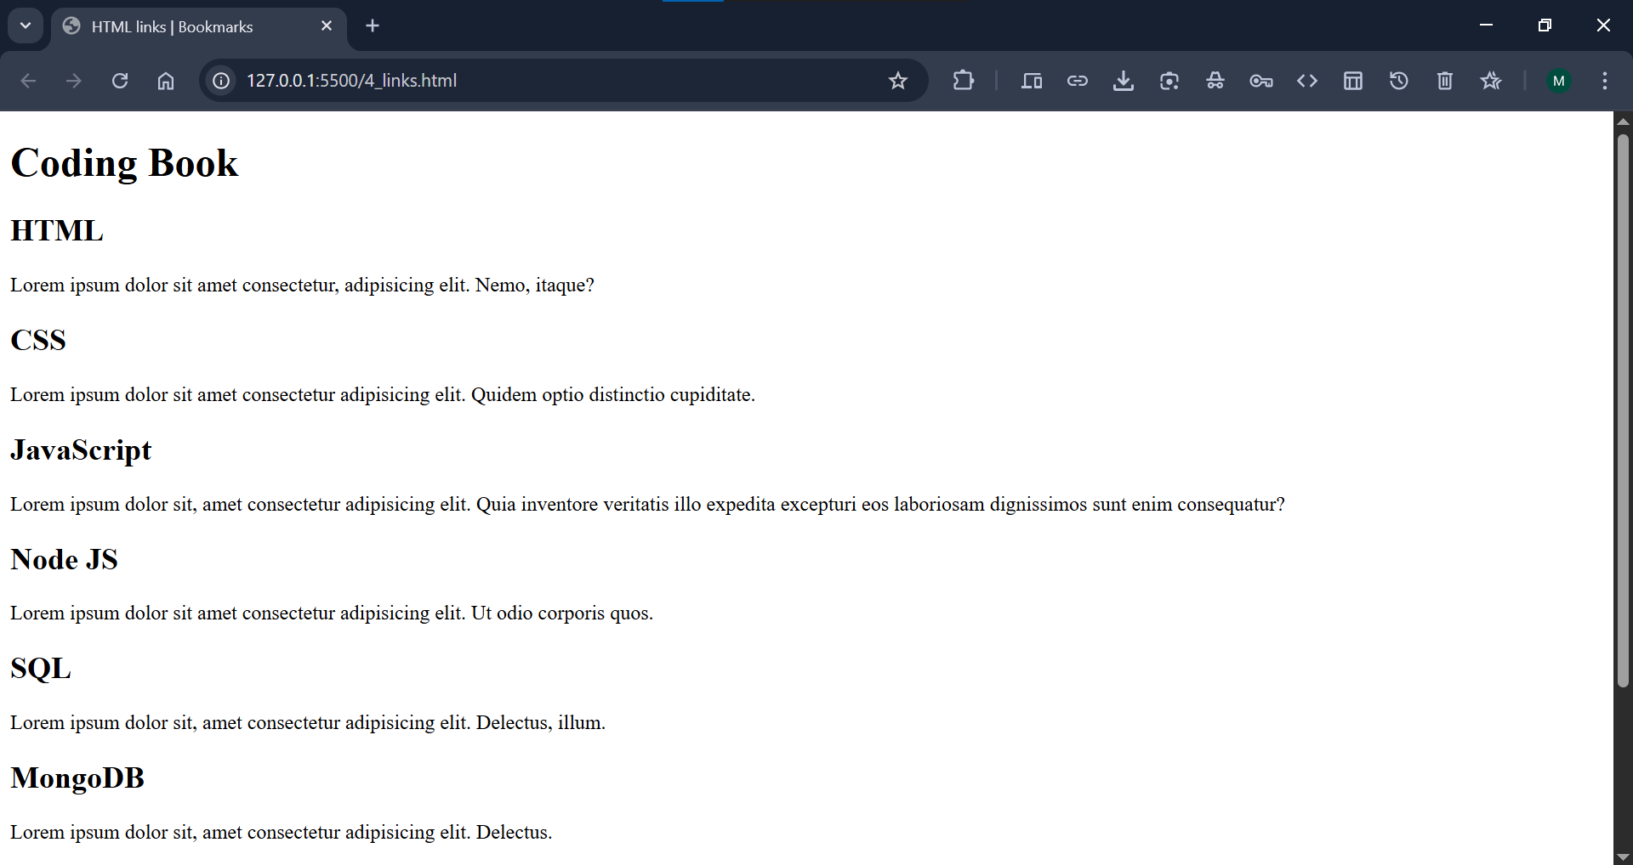

***Create bookmark links of different sections of a webpage at the top of webpage:***

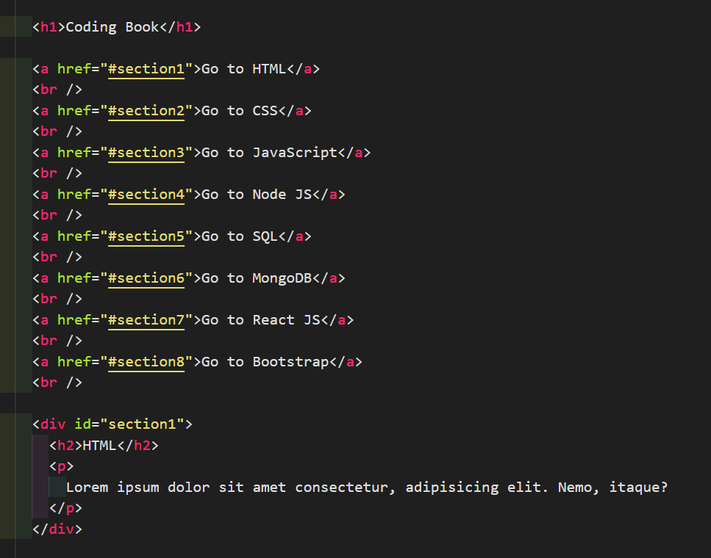

***Output of the above code:***

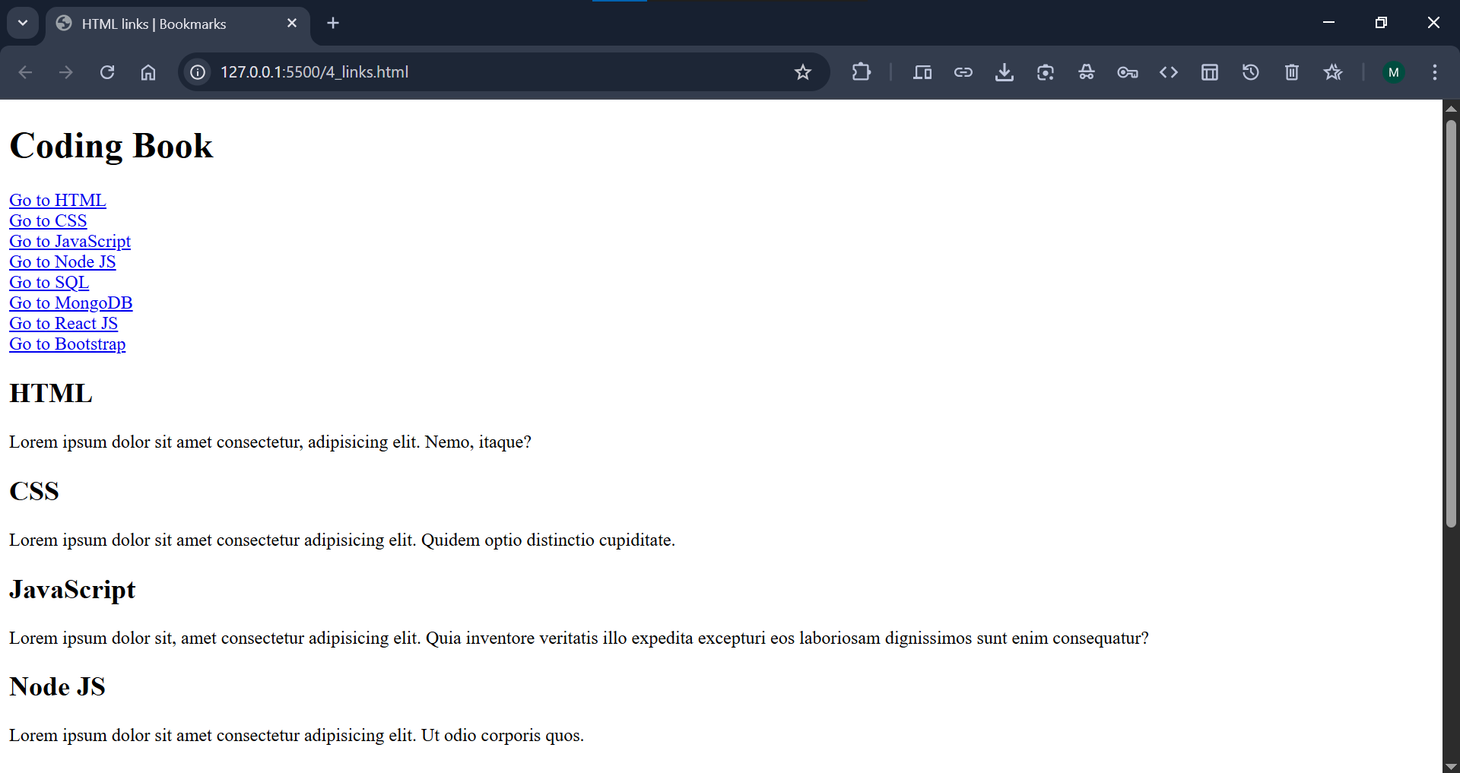

***If we want to go to the last section of a webpage just click on the last link and you jump to last section of this webpage.***

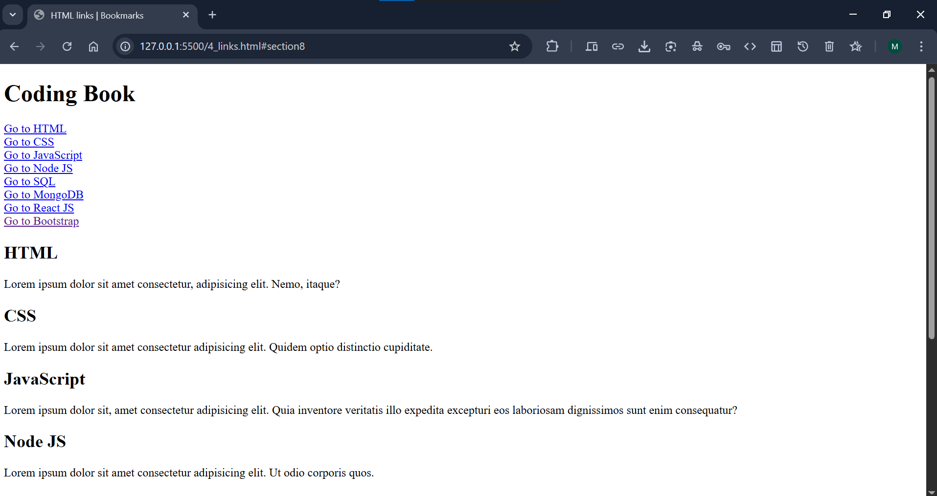

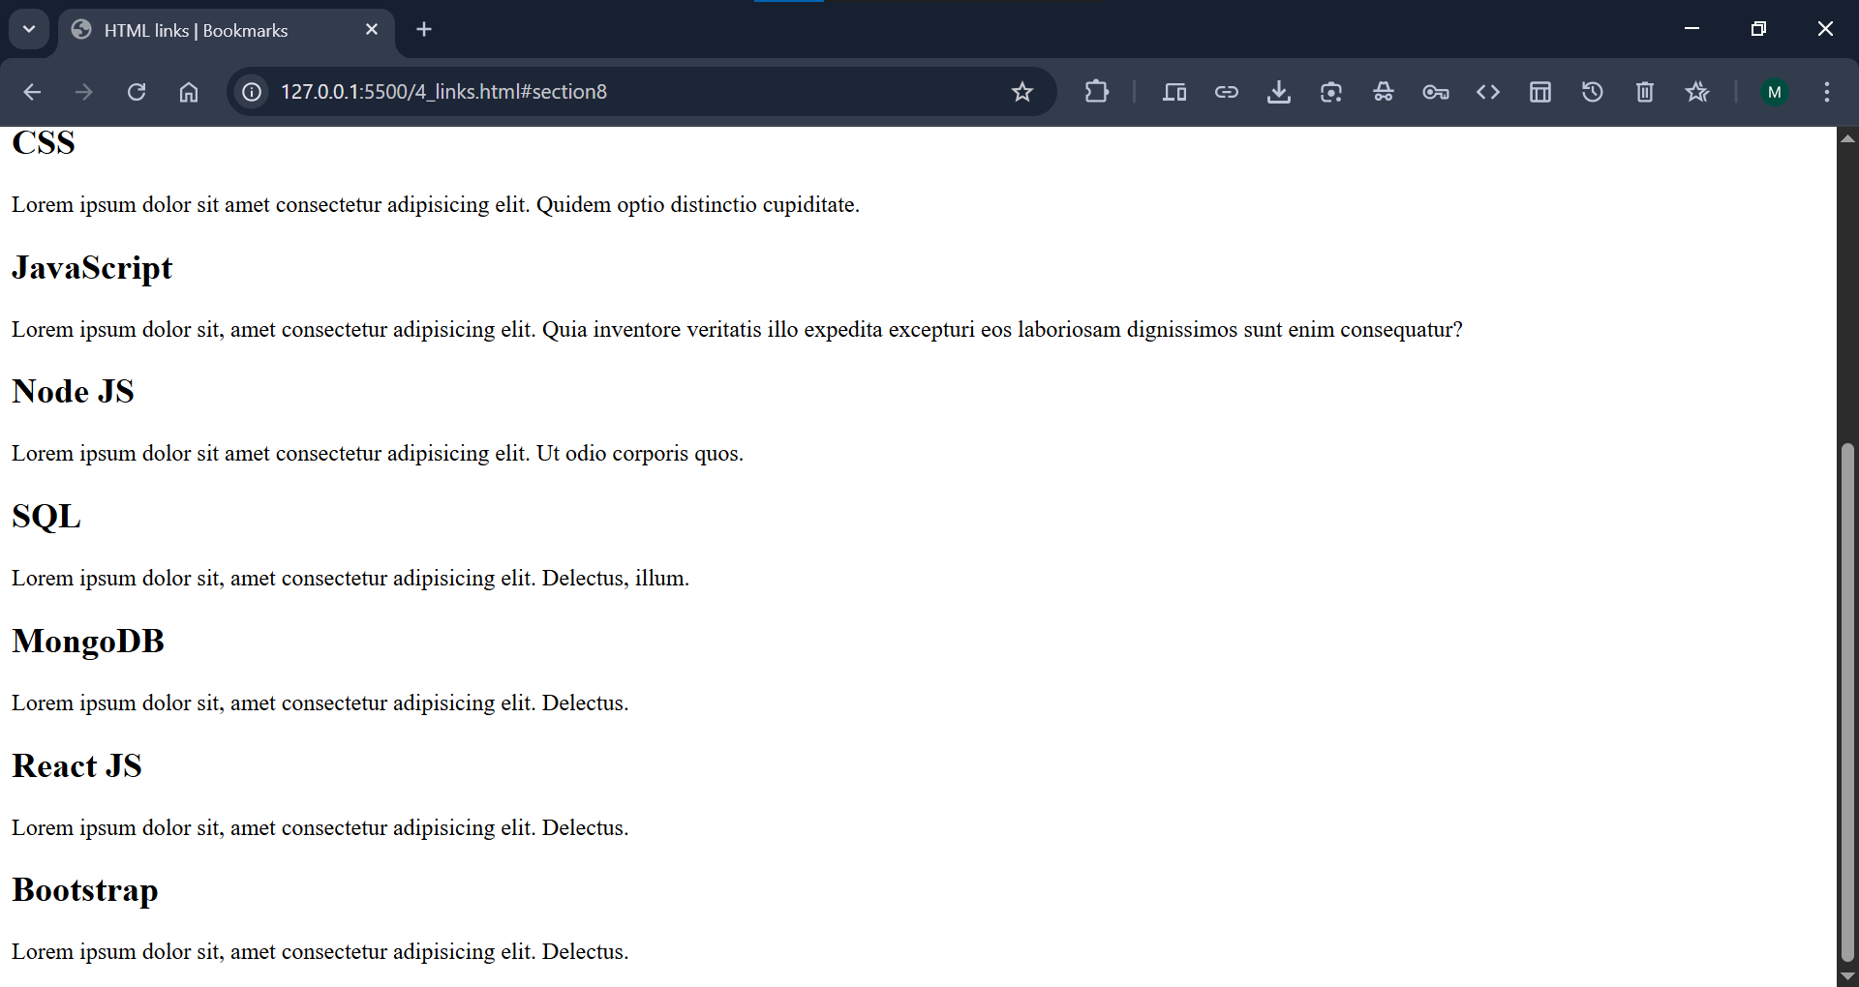

**Add Bookmark Link to Another Page:**

We can also add a link to a bookmark on/to another page:

**Code:**

***Add the bookmark link to another page.***

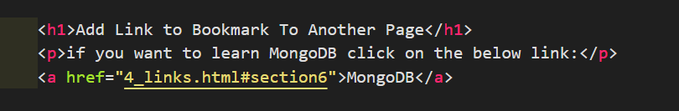

**Output:**

***Output of the above code:***

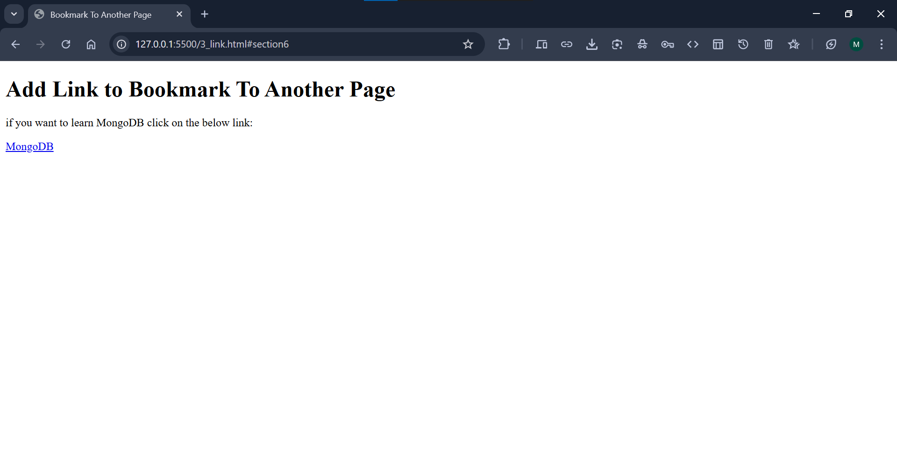

***When we click on the above link, we will redirect to the specific section of the page that linked:***

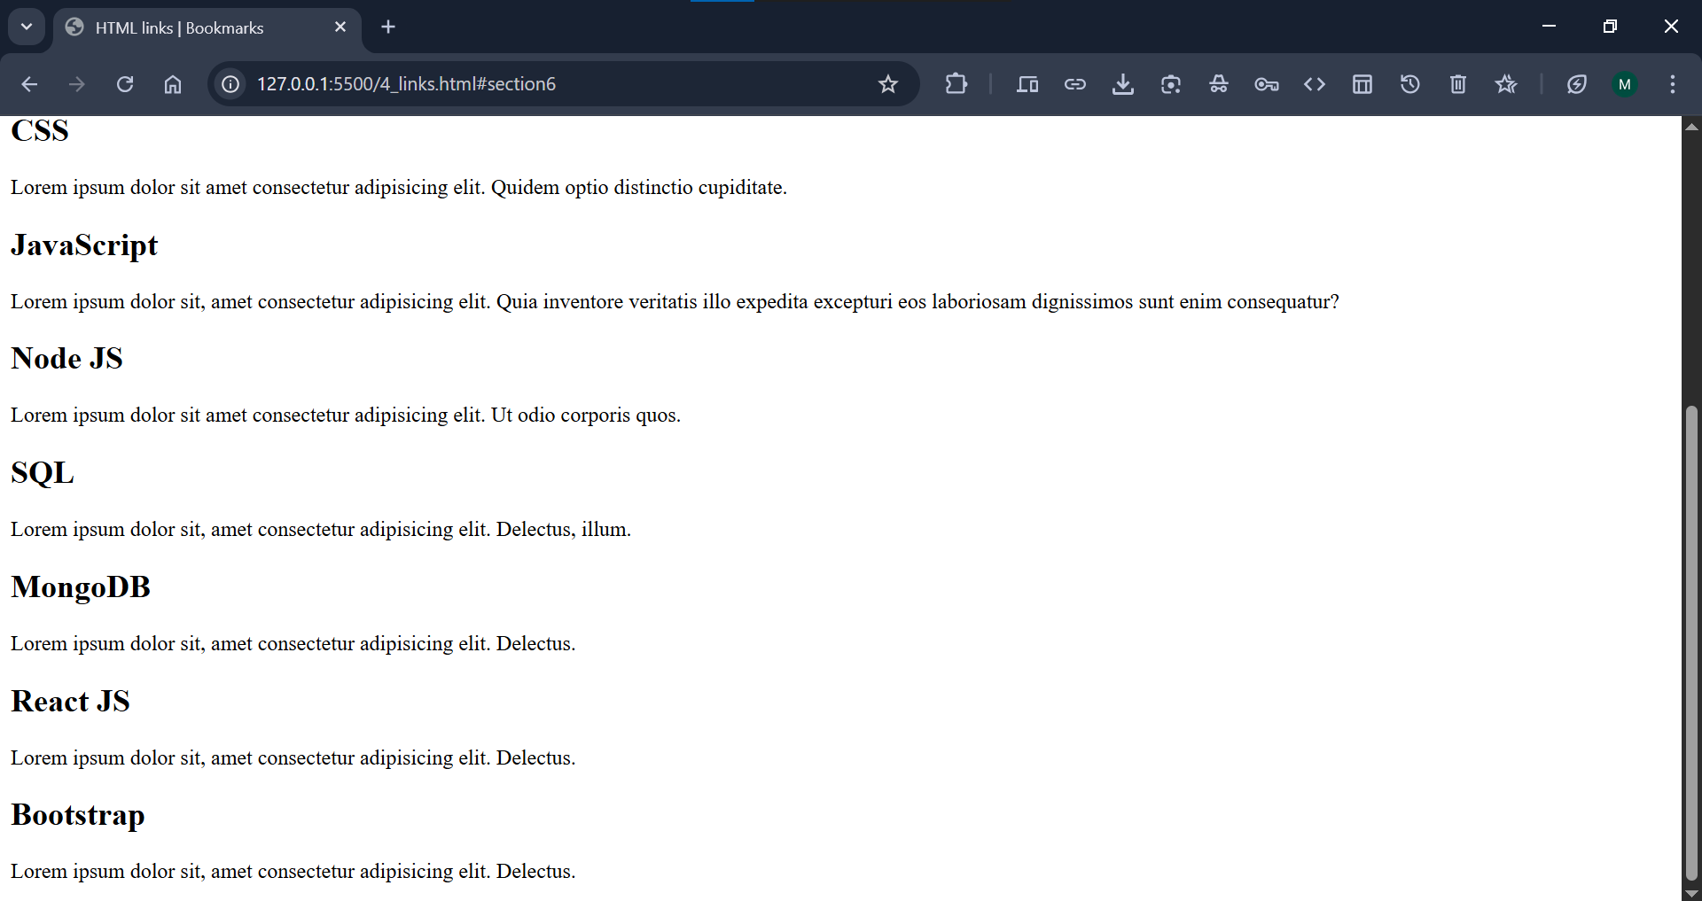

**Summary:**

1. Use the id attribute (id="value") to define bookmarks in a page
2. Use the href attribute (href="#value") to link to the bookmark

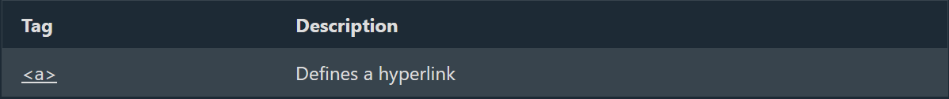

**Reference:**

<https://www.w3schools.com/tags/tag_a.asp>